Day 44: 17-12-2025
CI and CD : Continuous integration and Continuous deployment or delivery

Dev1

Dev2 Shared repository <CI/CD

Dev3

AWS
EC2 instance : AWS module which provide virtual lab.

Deploy react js project in EC2 instance
1st Option
- Install git
- Install node js
- Pull react js project from github account
- And run the project
2nd option
- Install docker
- Pull your docker image which deployed in docker hub and
- Run on ec2 instance

Creating EC2 instance to run react js docker image

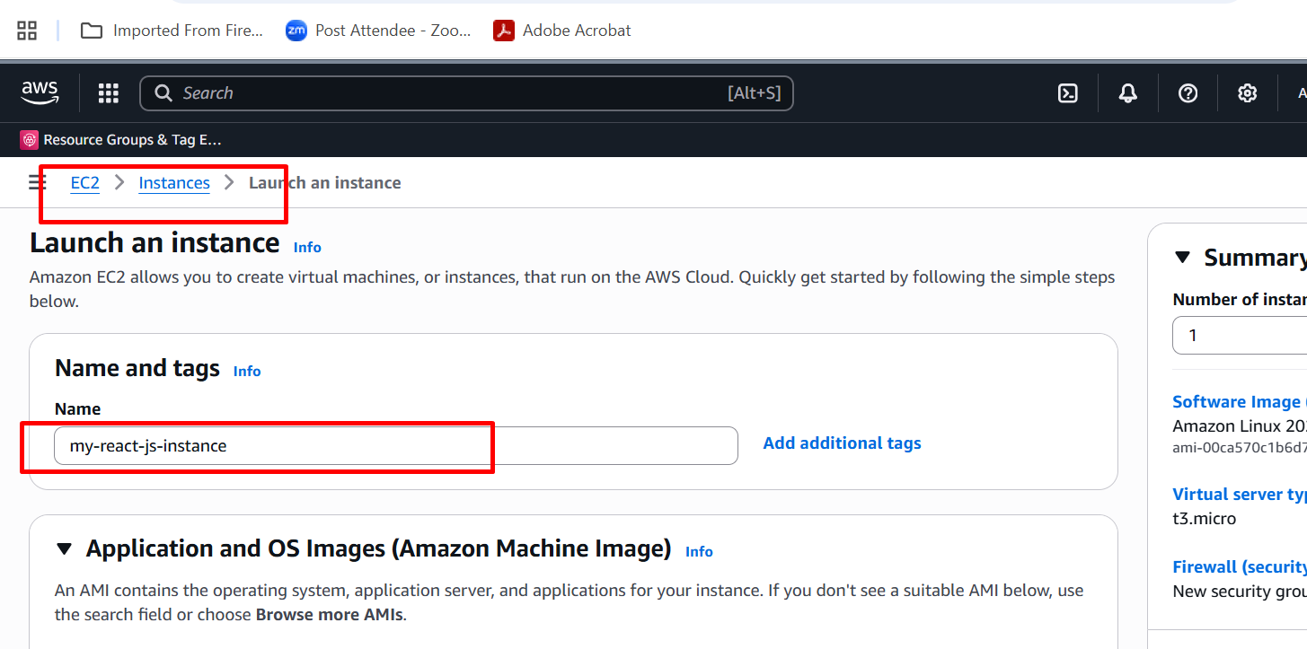

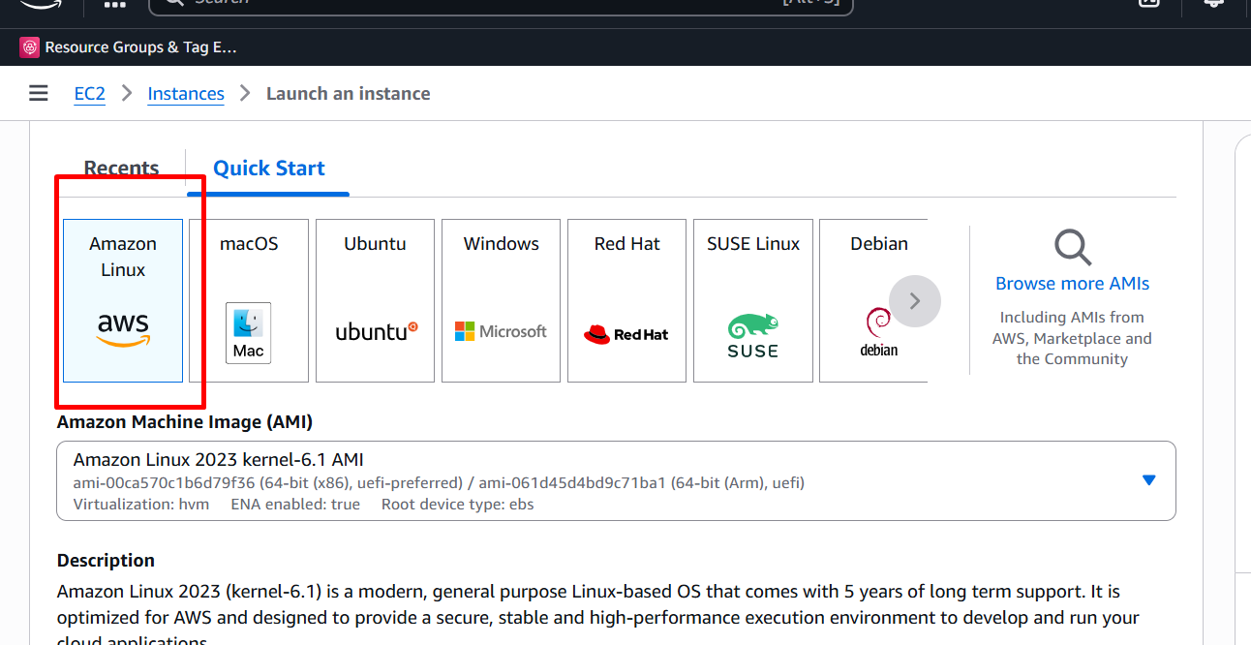

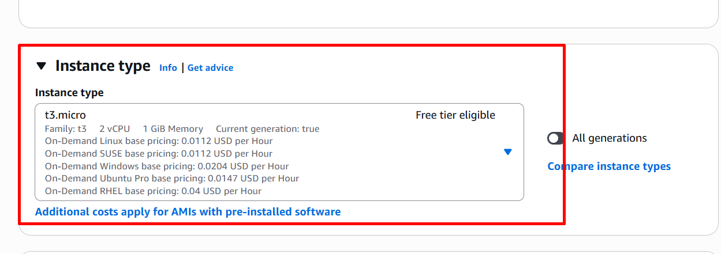

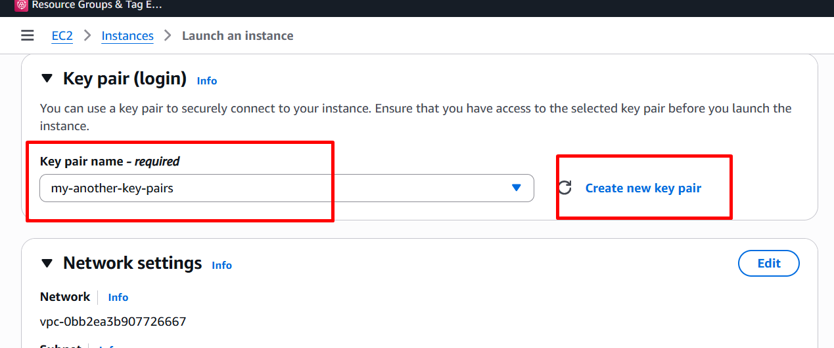

It open 80 port number

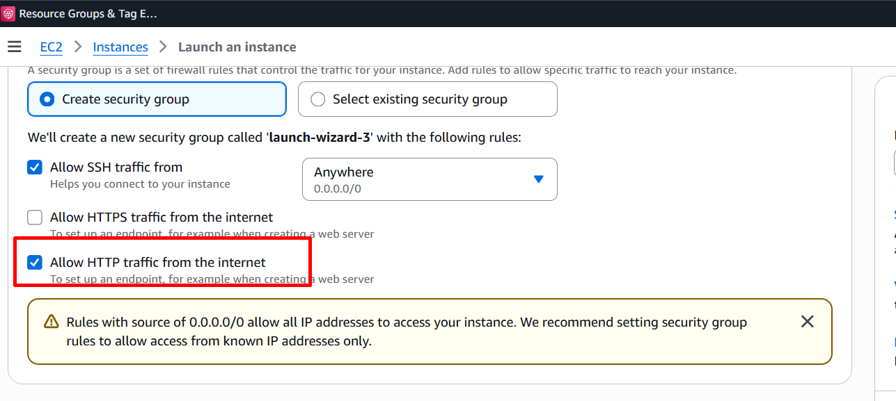

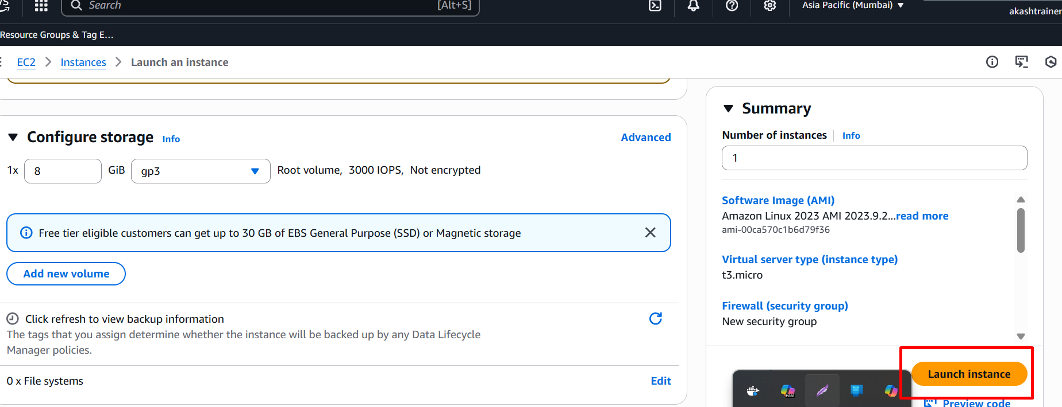

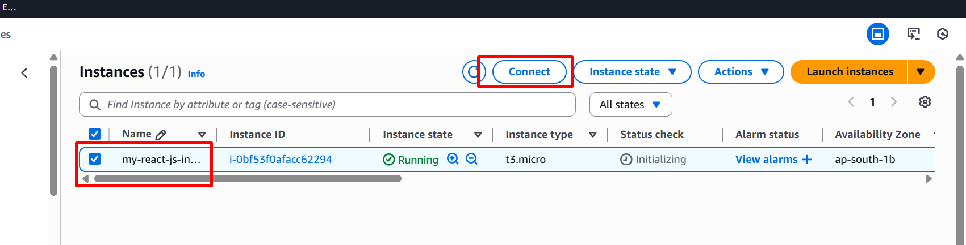

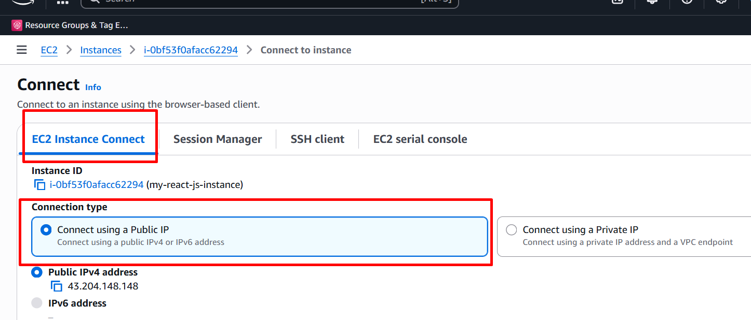

Dev1 dev1-branch

Dev2 Remote Repository ---review we merge to main
dev2 -branch
Dev3
dev3-branch

Remote repository is github

CI/CD tools is Jenkin

Jenkin pipe line job which connect to github remote repository we pull the code whenever any changes happen in main branch

Docker-compose file which is responsible to run more than one container.
docker-compose down
docke-compose up --build
my be same EC2instance machine or different machine we deploy
container become up
Cache concept:
Cache is improve the performance while calling database, api, any other method invocation which consider as very expensive class.
JDBC
Statement :
PreparedStatement :
It is an temporary memory to hold the data to avoid call to external services.
In spring boot service layer always call DAO layer. Dao layer develop using custom query or repository ie interfaces provided by spring boot.

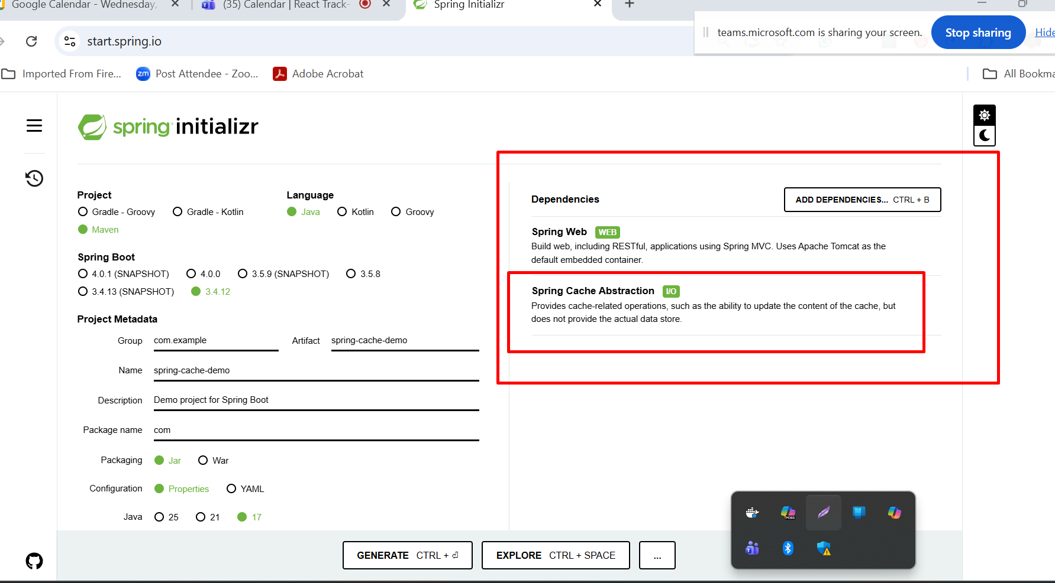

Spring scheduling

Scheduling is use to execute particular task on specific time or trigger with explicitly event occurs.
Cron jobs.

Few Scheduling we can use in spring boot
- fixedRate - equal to sleep method after every fixed time like 1min or 4 min etc. setInterval()
- fixedDelay : run again after fixed time like delay or timeInterval()
- cron jobs : 6

Spring boot profiling

Using spring boot profile same application we run in different environments. Any configuration details which we store in application.properties or application.yml file. Which we need to change base upon environment.
Development mode -- mysql database
Testing mode H2 database in memory data
Production mode - oracle

